Detailed Screen Descriptions

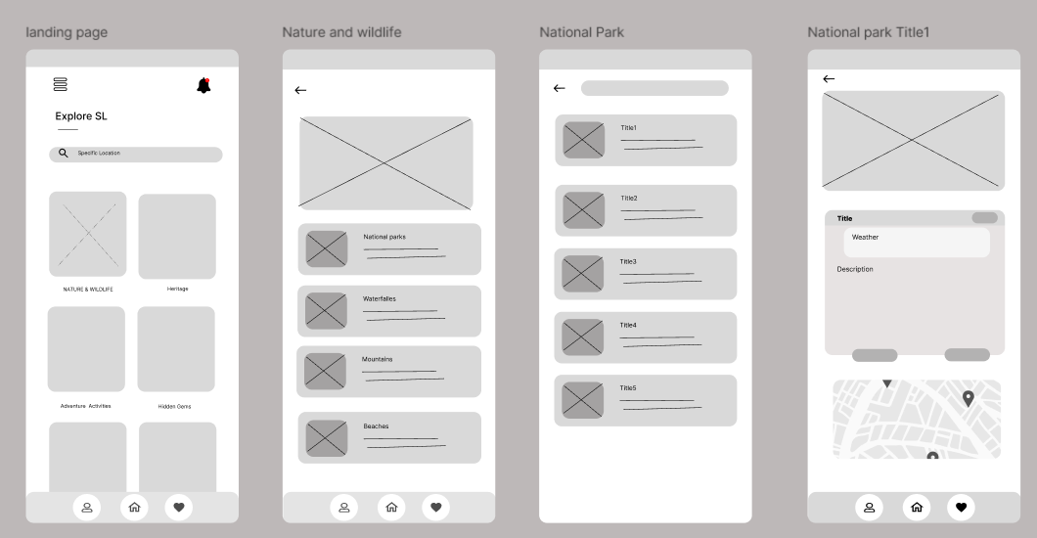

1. Home/Landing Page

This is the initial screen that users see upon launching the app. It sets the tone and offers a clear navigation path.

Features:

* Search Bar: Enables users to quickly search for locations, attractions, or points of interest.
* Category Buttons: Quick access to different sections of the app (e.g., Nature, Heritage, Activities).
* Navigation Menu: Provides access to other important areas such as user profiles, settings, and help.

2. Nature & Wildlife Screen

This screen focuses on showcasing natural attractions such as national parks, waterfalls, mountains, and beaches.

Features:

* Category Filters: Users can filter the content by types of natural attractions.
* Visual Thumbnails: Each category is represented by images to make the selection process intuitive.
* Brief Descriptions: Each thumbnail includes a short description or title to give users a quick overview.

3. National Park List Screen

Once a user selects the Nature & Wildlife category, they are presented with a list of national parks.

Features:

* List View: A vertically scrollable list that displays national parks with essential details such as name, location, and a preview image.
* Sorting Options: Users can sort the list based on popularity, distance, or alphabetical order.
* Call-to-Action Buttons: Options to “View Details” or “Save” a park for later reference.

4. National Park Details Screen

This screen provides in-depth information about a selected national park.

Features:

* High-Quality Images: A carousel of images to give users a visual tour of the park.
* Detailed Description: Information about the park’s history, significance, and notable features.
* Map Integration: An interactive map to show the park’s location and nearby points of interest.
* Weather Widget: Displays current weather conditions to help users plan their visit.
* User Reviews and Ratings: A section for visitors to read and leave feedback.

User Flow and Navigation

* Seamless Transition: Users start at the Home Page, where they can easily access different categories. Upon selecting a category like Nature & Wildlife, they are directed to a list screen that provides more options.
* Intuitive Design: Every screen is designed with user experience in mind, ensuring that navigation is simple and information is easy to find.
* Consistent Layout: The design elements, such as fonts, colors, and button styles, are consistent throughout the app to create a cohesive look and feel.

Design Rationale and Tools

* + Visual Clarity: The wireframes emphasize a clean and uncluttered design to ensure that users can focus on the content without distractions.
  + Feedback-Driven: The design decisions are based on user feedback and usability testing, ensuring that the app meets user needs.
  + Tools Used: The wireframes were created using [insert tool name, e.g., Figma or Adobe XD], which allowed us to iterate quickly and collaborate effectively with the team.